

STANDARD TEMPLATE
STANDARD FORM OF AGREEMENT for Use by World Bank Borrowers
Procurement of Supplies through UNOPS under Bank-Financed Projects
v.1
August 2016

This document is subject to copyright.

This document may be used and reproduced for non-commercial purposes only. Any commercial use, including without limitation reselling, charging to access, redistribution, or for derivative works such as unofficial translations based on these documents, is not allowed.

Foreword

This Standard Form of Agreement is the result of cooperation between the World Bank (“the Bank”) and the United Nations Office for Project Services (“UNOPS”).

The approval of this standard template was done by respective signatures of the World Bank Vice President for Operations Policy and Country Services and UNOPS Under-Secretary General and Executive Director on 22 August, 2016.

This form can be used for the procurement of any type of materials and equipment, except for vehicles, (“Supplies”), either through a call off under the existing long term agreements with UNOPS’ suppliers (the “LTAs”), or through the new procurement processes for the items not covered by the LTAs. For procurement of vehicles, the standard template for Vehicles should be used. UNOPS will offer the items ordered by the Borrower under this Agreement on similar business terms and unit rates as those afforded to the World Bank for its own corporate purposes procurement. To initiate the process, the Borrower can contact UNOPS country office, or register online at UNOPS’ procurement portal UN WebBuy www.unwebbuy.org.

This form can be used for a one time purchase or as a framework arrangement when procurement strategy for a project includes more than one time purchase of Supplies during the life of the project. The Agreement can be signed at the beginning of the project and individual purchase orders are placed by the Borrower depending on the schedule in the procurement plan and up to the cumulative price ceiling (“Total Funding Ceiling”) set up in the Agreement. The completion date of the Agreement and the delivery of the last order cannot exceed the project’s closing date.

The text shown in Italics is “Notes to Users”, which provide guidance to the implementing entity of the Borrower and to the UN agency task team in preparing a specific Agreement. These italicized Notes should be deleted from the final version prior to signing of the Agreement.

Those wishing to submit comments or questions on this document, or obtain additional information or guidance on the use of this template, should contact unagencies@worldbank.org

For questions or guidance concerning UNOPS, please contact:

Integrated Practice Advice and Support (IPAS)  United Nations Office for Project Services  Marmorvej 51, 2100  Copenhagen, Denmark  e-mail: ipas.legal@unops.org | Washington Liaison Office  United Nations Office for Project Services  1775 K Street NW  Washington, DC 20006, U.S.A.  e-mail: Washington.Office@unops.org

The Agreement form for use by the Borrowers starts from the next page

Public disclosure is authorized after the signing

AGREEMENT
FOR PROCUREMENT OF SUPPLIES

Project Name: ___________________
Project Closing Date: _________________
Reference No. [per Procurement Plan]

UNOPS Case Number No. _____________

Loan/Credit/Grant No. ____________
Financing Agreement Date: [date/month/year]_______

between

THE GOVERNMENT OF [insert the country name]

and the

UNITED NATIONS OFFICE FOR PROJECT SERVICES (UNOPS)

Dated: date/month/ year

Insert Borrower’s logo
FORM OF AGREEMENT

THIS AGREEMENT (together with all Annexes hereto, this “Agreement”) is entered into between THE GOVERNMENT OF ______________________________ by and through its [Ministry of ___________________________] (the “Government”), the UNITED NATIONS OFFICE FOR PROJECT SERVICES, a subsidiary organ of the United Nations, with its headquarters in Copenhagen, Denmark (“UNOPS”, or the “UN Partner” together with the Government the “Parties” and each a “Party”).

WHEREAS

- UNOPS, as a subsidiary organ of the United Nations, acts as a central resource of the United Nations in procurement, contracts management and other capacity development activities, in accordance with the Host Country Agreement concluded between the Government and UNOPS (the “Basic Agreement”). If the Government has not concluded the Basic Agreement with UNOPS, references to the “Basic Agreement” shall, for the purposes of the present Agreement refer to either the Standard Basic Assistance Agreement concluded between the Government and UNDP or the Revised Standard Technical Assistance Agreement concluded with the UN and specialized agencies.

- The Government, working with its development partners, including UNOPS and the World Bank (the “Bank”), is implementing [project name] (the “Project”). As part of Project implementation, the Government has asked UNOPS, and UNOPS has agreed to supply the items listed in Annex I (“Supplies”).
- The Government has received funds from the Bank (the “Financing”) pursuant to a legal agreement for the Project (the “Financing Agreement”) towards the cost of Supplies.
NOW, THEREFORE, the Parties agree as follows:
- The Government intends to apply a portion of the proceeds of the Financing up to a total amount of US$ insert amount in words] ([insert amount in figures]) (the “Total Funding Ceiling”), to eligible payments under this Agreement. The Total Funding Ceiling is the Parties’ best estimate (as of the date of signing of this Agreement) calculated for the entire quantities required for Project implementation. A detailed calculation of the Total Funding Ceiling is provided in Annex I.
- This Agreement is signed and executed in English, and all communications, notices and modifications related to this Agreement shall be made in writing and in the same language.

- This Agreement becomes effective on the date it is signed by both Parties (the “Effective Date”), and will remain effective until [insert the date which cannot exceed the Project’s closing date] (the “Completion Date”), unless otherwise agreed by the Parties in writing.
- The Government designates [name, title], and UNOPS designates [names, title] as their respective authorized representatives for the purpose of coordination of activities under this Agreement. The contact information for the authorized representatives is as following:
- Government representative: [insert phone, e-mail and fax]
- UNOPS representative: [insert phone, e-mail and fax]

- This Agreement shall be interpreted in a manner that ensures it is consistent with the Convention on the Privileges and Immunities of the United Nations, 1946 (the “General Convention”), and the Basic Agreement.
- Nothing contained in or relating to this Agreement shall be deemed a waiver, express or implied, of any of the privileges and immunities of the United Nations, including UNOPS, under the General Convention, the Basic Agreement, or otherwise.
- Any dispute, controversy or claim between the Parties arising out of or relating to this Agreement, including third party claims, shall be dealt with in accordance with the Basic Agreement. Any claims by the Government against UNOPS’ supplier pursuant to supplier’s warranties and any claims related to a commercial contract where UNOPS is a party to a signed contract will be handled in accordance with the terms of such contract.
- For the Project’s coordination purposes, the Bank’s staff contact information is as follows:
Attn. : [name of the Task Team Leader]
Telephone: ____________
e-mail: _______________@worldbank.org

- The following documents form an integral part of this Agreement:
- The General Conditions of Agreement;
- Annexes:
Annex I Supply Requirements;
Annex II Pro Forma Invoice;
Annex III Acceptance Document; and
Annex IV Reporting Requirements.

PAYMENT INFORMATION:
By bank wire transfer:
UNOPS Case Number: [Country]- [Project Number]

ACCOUNT NAME: UNOPS USD Account
CURRENCY USD
BANK NAME JP Morgan Chase
BANK ADDRESS 277 Park Avenue, 23rd Fl., New York, NY 10172 USA

ACCOUNT NUMBER:
SWIFT CODE: CHASUS33
ABA ROUTING: 021000021

IN WITNESS WHEREOF, the Parties hereto have executed this Agreement.
[The Government of _______  The Ministry of _________________]  Name: __________________  Title: _________________  Date: ___________________ | United Nations Office for Project Services (UNOPS)  Name: ________________  Title: _________________  Date: __________________

The text of the clauses in these General Conditions of Agreement shall not be modified

GENERAL CONDITIONS OF AGREEMENT

Definitions

- In this Agreement, the following terms shall have the following meaning:

- Acceptance Document means a written record of the Government confirming the acceptance of the Supplies delivered by the UN Partner in accordance with the Pro Forma Invoice and the terms of this Agreement.
- Delivery Schedule means the delivery time table to the named Destination and according to the Incoterms agreed for each supply item as set out in the relevant Pro Forma Invoice.
- Destination means place of delivery of Supplies in the Government’s country.
- Pro Forma Invoice means the document that the UN Partner issues once the Government accepts and confirms the Quotation confirming the Supply items, unit costs and planned delivery schedule.
- Quotation means a price quote prepared by the UN Partner in response to an on-line order form or written request submitted by the Government in accordance with Annex I detailing the specific items the Government wishes the UN Partner to supply.

Scope and General Obligations of the Parties

- The UN Partner agrees to:

- procure Supplies set out in Pro Forma Invoice attached hereto as Annex II, in conformity with the applicable specifications and in the indicated quantities; and
- deliver Supplies in accordance with the delivery information specified in the applicable Pro Forma Invoice agreed between the UN Partner and the Government.
- The Government agrees to:
- make timely and complete payment to the UN Partner of all amounts, up to the Total Funding Ceiling, and within the validity dates stated in the Pro Forma Invoice;
- provide required support in connection with the UN Partner’s obligations under this Agreement, including in obtaining or assisting with permits, licenses, import approvals, and other official approvals, or furnish powers of attorney or other authorizations to the UN Partner to deliver services related to Supplies, and cooperate in a timely and expeditious manner;
- use Supplies exclusively for official business in support of the implementation of the Project, and cover all expenses related to Supplies’ insurance, maintenance and operation incurred from the date of the Acceptance Document (Annex III); and
- obtain and maintain all appropriate third party liability claims insurance in connection with the use of Supplies.
Total Funding Ceiling and Payments
- Cumulative payments (disbursements) by the Government under this Agreement shall not exceed the Total Funding Ceiling unless it is revised through a written amendment approved by the Bank. The UN Partner takes note that the Government’s disbursements under this Agreement are subject, in all respects, to the terms and conditions of the Financing Agreement; and no party other than the government shall derive any rights from the Financing Agreement or have any claim to the Financing proceeds.

- The payments under this Agreement shall be made by the Government upon receipt of the Pro Forma Invoice (Annex II). All payments to the UN Partner under this Agreement will be made in United States dollars. The UN Operational Rate of Exchange shall be used for converting expenditures to suppliers made in other currencies.

- The UN Partner will maintain a separate identifiable fund code (ledger account or “Account”) to which all UN Partner receipts and disbursements for the purposes of this Agreement will be recorded. The ledger account shall be subject exclusively to the UN Partner’s internal and external audit in accordance with the UN Partner’s regulations and rules. The Parties acknowledge that the UN Partner’s financial books and records are routinely audited in accordance with the internal and external auditing procedures laid down in the UN Partner’s financial regulations and rules, and that the external auditors of UN Partner are appointed by and report to the UN Partner’s policymaking organ, of which the Government is member. Throughout the term of this Agreement, the UN Partner will ensure that its audited accounts and the External Auditors’ Report are posted on its website within ten (10) Days of their becoming public documents by reason of being presented to the UN Partner’s policymaking organ.

- The UN Partner shall not be required to commence or continue any activities until the UN Partner has received the payments due in accordance with the payment schedule and it shall not be required to assume any liability in excess of such payments.

- Payments to the UN Partner shall not prejudice the Government’s right to dispute any amount claimed by the UN Partner and to adjust any future payment by the amount in dispute and inform the UN Partner accordingly. In such case, the Government will promptly notify the UN Partner and the Bank to arrive at a mutually acceptable solution.

Procurement and Terms of Delivery
- Supplies will be procured, shipped and delivered in accordance with the terms of this Agreement and the UN Partner’s regulations, rules, procedures, and administrative instructions for procurement and finance, including the rules on the use of any interest derived from funds disbursed under this Agreement.

- Supplies will be delivered as per the Incoterms as set out in the relevant Pro Forma Invoice issued by the UN Partner on the terms specified in Annex II. Each Pro Forma Invoice will specify the consignee of the Supplies following an agreement between the UN Partner and the Government. The UN Partner will not act as a consignee of the Supplies. The Government shall inform the UN Partner on the nominated representative to act as the consignee for the Supplies when placing an order with the UN Partner.

- UN Partner will inform the Government of any potential or actual delivery delay, including its likely duration and its cause(s), as soon as the UN Partner obtains information on such delay. The UN Partner will make good faith efforts to ensure that any actual delivery delays are minimized.
Warranties
- The UN Partner will procure Supplies under terms which will include all warranties that are appropriate in the circumstances and that expressly enable the Government to benefit directly from such warranties. The UN Partner will transfer the relevant warranties to the Government as part of the shipment documentation.
Report on Completion of Delivery
- Upon completion of each shipment of Supplies covered under the same Pro Forma Invoice, the UN Partner will notify the Government in writing to confirm the completion of procurement action and the use of funds.
- Upon the receipt of the notification, the Government will promptly prepare an acceptance document following the template set out in Annex III and will retain a signed original on file.
- The UN Partner will not accept the return of any purchases procured on behalf of the Government.
Reporting

- The UN Partner will keep accurate accounts and records in respect of the funds made available under this Agreement, in accordance with the UN Partner’s financial regulations and rules and in such form and detail as will clearly identify all relevant charges and costs for corresponding deliverables.

- The UN Partner will provide written Progress Reports to assist the Government in monitoring implementation progress towards the provision of Supplies, and the remaining balance under the Total Funding Ceiling (a “Progress Report”). The frequency of the reporting and the reporting template are set out in Annex IV.

- Upon request from the Government and following consultations between the UN Partner and the Government, the UN Partner may furnish supplemental information or documentation to provide additional details.

Force Majeure
- Either Party prevented by force majeure from fulfilling its obligations shall not be deemed in breach of such obligations. The said party shall use all reasonable efforts to mitigate consequences of force majeure. At the same time, the Parties shall consult with each other on modalities of further execution of the Agreement. Force majeure as used in this Agreement is defined as natural catastrophes such as but not limited to earthquakes, floods, cyclonic or volcanic activity; war (whether declared or not), invasion, act of foreign enemies, rebellion, terrorism, revolution, insurrection, military or usurped power, civil war, riot, commotion, disorder; ionizing radiation or contaminations by radioactivity; other acts of a similar nature or force.
Fraud and Corruption Prevention
- In the event that the Government, the UN Partner, or the Bank becomes aware of information that indicates the need for further scrutiny of the procurement or delivery process or the use of Financing provided under this Agreement (including non-frivolous allegations that reasonably indicate the possibility that corrupt, fraudulent, coercive or collusive practices may have occurred), the entity that has become aware of such information will promptly notify the other two.
- In such case, this information will be brought promptly to the attention of the appropriate official or officials of the government, the UN Partner, and the Bank.
- After consultation with the Government and the Bank, the UN Partner will, to the extent the information relates to actions within the authority or accountability of the UN Partner, take timely and appropriate action in accordance with its applicable regulations, rules, and administrative instructions, to investigate this information. For greater clarity on this matter, the Parties agree and acknowledge that the UN Partner shall have no authority to investigate Government officials or officials or consultants of the Bank.
- To the extent such investigation confirms that corrupt, fraudulent, collusive or coercive practices have occurred and to the extent that remedial action is within the authority of the UN Partner, the UN Partner will take timely and appropriate action in response to the findings of such investigation, in accordance with its accountability and oversight framework and established procedures, including its financial regulations and rules, where applicable.
- To the extent consistent with the UN Partner’s internal control framework and established procedures, the UN Partner will keep the government and the Bank regularly informed by agreed means of actions taken, and the results of the implementation of such actions, including where relevant, details of any recovered amounts. The government will consult with the Bank and provide payment instructions to the UN Partner with respect to such amounts.
- For the purposes of this Agreement, the following definitions shall apply:

(i) “corrupt practice” is the offering, giving, receiving or soliciting, directly or indirectly, of anything of value to influence improperly the actions of another party;

(ii) “fraudulent practice” is any act or omission, including misrepresentation, that knowingly or recklessly misleads, or attempts to mislead, a party to obtain financial or other benefit or to avoid an obligation;

(iii) “collusive practice” is an arrangement between two or more parties designed to achieve an improper purpose, including to influence improperly the actions of another party;

(iv) “coercive practice” is impairing or harming, or threatening to impair or harm, directly or indirectly, any party or the property of the party to influence improperly the actions of a party.

- In the event that the Government or the Bank reasonably believes that the UN Partner has not complied with the requirements of this section, the Government or the Bank may request direct consultations at a senior level between the Bank, the Government and the UN Partner in order to obtain assurances, in a manner consistent with the UN Partner’s oversight and accountability framework and respecting appropriate confidentiality, that the UN Partner’s oversight and accountability mechanisms have been or will be fully applied. Such direct consultations may result in an understanding between the Government, the Bank, and the UN Partner, on any further actions to be taken and the timeframe for such actions. The Parties take note of the relevant provisions in the Financial Regulations and Rules of the UN Partner.

- The Parties agree and acknowledge that nothing in this section shall be deemed to waive or otherwise limit any right or authority of the Bank or any other entity of the World Bank Group under the Financing Agreement or otherwise, to investigate allegations or other information relating to possible corrupt, fraudulent, coercive, collusive or obstructive practices by any third party, or to sanction or take remedial action against any such party which the World Bank Group has determined to have engaged in such practices; provided however that in this section, “third party” does not include the UN Partner. To the extent consistent with the UN Partner’s oversight framework and established procedures, and if requested by the Bank, the UN Partner shall cooperate with the Bank or such other entity in the conduct of such investigations.

- (a) The UN Partner requires any party with which it has a long-term arrangement or to which it intends to issue a purchase order or a contract to disclose to the UN Partner whether it is subject to any sanction or temporary suspension imposed by any organization within the World Bank Group. The UN Partner will give due regard to such sanctions and temporary suspensions, as disclosed to it when issuing contracts in connection with the Supplies under this Agreement.

- (b) If the UN Partner intends to issue a contract in connection with the Supplies under this Agreement with a party which has disclosed to the UN Partner that it is under sanction or temporary suspension by the World Bank Group, the following procedure will apply: (i) the UN Partner will so inform the Government, with a copy to the Bank, before signing such contract; (ii) the Government and the Bank then may request direct consultations at a senior level, if required, between the Bank, the Government and the UN Partner to discuss the UN Partner’s decision; and (iii) if after such consultation, the UN Partner elects to proceed with the issuance of the contract, the Bank may inform the UN Partner by notice, with a copy to the Government, that the proceeds of the Financing may not be used to fund such contract.

- Any funds received by the UN Partner under this Agreement that were to be used to fund a contract in respect of which the Bank has exercised its rights under this section, shall be used to defray the amounts requested by the UN Partner in any subsequent Payment Request, if any, or will be treated as a balance in favour of the Government in the calculation of the final balances upon completion or early termination of this Agreement.

Settlement of Disputes between the Parties

- This Agreement shall be governed by general principles of international law, which shall be deemed to include the UNIDROIT General Principles of International Commercial Contracts (2010). Any dispute, controversy or claim arising out of or relating to this Agreement shall be resolved in accordance with the relevant provisions of the Basic Agreement or, failing such provision, if not settled by negotiation or other agreed mode of settlement, shall be submitted to arbitration at the request of either Party. Each Party shall appoint one arbitrator, and the two arbitrators so appointed shall appoint a third, who shall be the chairman. If within thirty days of the request for arbitration either Party has not appointed an arbitrator or if within fifteen days of the appointment of two arbitrators the third arbitrator has not been appointed, either Party may request the President of the International Court of Justice to appoint an arbitrator. The procedure of the arbitration shall be fixed by the arbitrators, and the expenses of the arbitration shall be borne by the Parties as assessed by the arbitrators. The arbitral award shall contain a statement of the reasons on which it is based and shall be accepted by the Parties as the final adjudication of the dispute.

Termination
- This Agreement may be terminated by either Party upon written notice to the other and only at the planning stage. In this connection, termination shall not affect any Pro Forma Invoices already issued by the UN Partner.
- The provisions of this Agreement will survive expiration or termination to the extent necessary to permit an orderly settlement of accounts between the Parties.

Amendments and Modifications
- This Agreement may be altered, modified or amended only by written instrument duly executed by both Parties.
- Amendments to, or cancellation of, or reduction in quantities in connection with binding agreements already entered into by the UN Partner at the time such amendment, cancellation, reduction or change is proposed, may only be undertaken with the consent of the UN Partner. The Government is responsible for payment in advance of any resulting costs (including but not limited to any penalties imposed by the UN Partners’ suppliers or service providers).
Notices
- A notice will be deemed “received” twenty-four (24) hours after it is given.

ANNEX I

SUPPLIES REQUIREMENTS

The Government may request a quotation for Supplies by contacting UNOPS country offices, or directly through UNOPS’ online procurement portal, UN Web Buy. UN Web Buy is accessible by registering for an account at www.unwebbuy.org.

The process is as follows:

Step 1- By the Government

Register for an account at www.unwebbuy.org or contact the UNOPS representative identified in paragraph 4 (b) of the Form of Agreement.

Browse through the UN Web Buy catalogue to identify the Supplies needed, the configuration required, and proceed to create a quotation base on the selection(s) made. Alternatively, the Government may engage UNOPS representative to assist with this process to prepare the following:

the list of Supplies, parts and relevant warranties selected from UN Web Buy on-line catalogue at www.unwebbuy.org, indicating any requirements for related services such as pre-shipment inspections, special shipment requests etc.;

desired quantities for the selected Supplies, and related parts, manuals. Please note that the quantities and specifications can be adjusted at the time of UNOPS placing individual orders with its suppliers. Please be mindful of the minimum and multiple quantities of items as indicated in the catalogue as these are based on UNOPS’ long term agreements with suppliers;

indication of appropriate transportation/shipping requirements including INCOTERM. Please make sure that the requested Delivery Date of the last shipment does not exceed the Project’s closing date;

Price quotations attained from UN Web Buy for all the required Supplies, including estimate for Freight & Insurance Costs.
Please submit the above to UNOPS for a Quotation.

Step 2 – By UNOPS

UNOPS will review the request and provide a Quotation online or through the country office. A template Quotation is provided below for ease of reference. This Quotation will form the basis of the Pro Forma invoice attached hereto as Annex II.

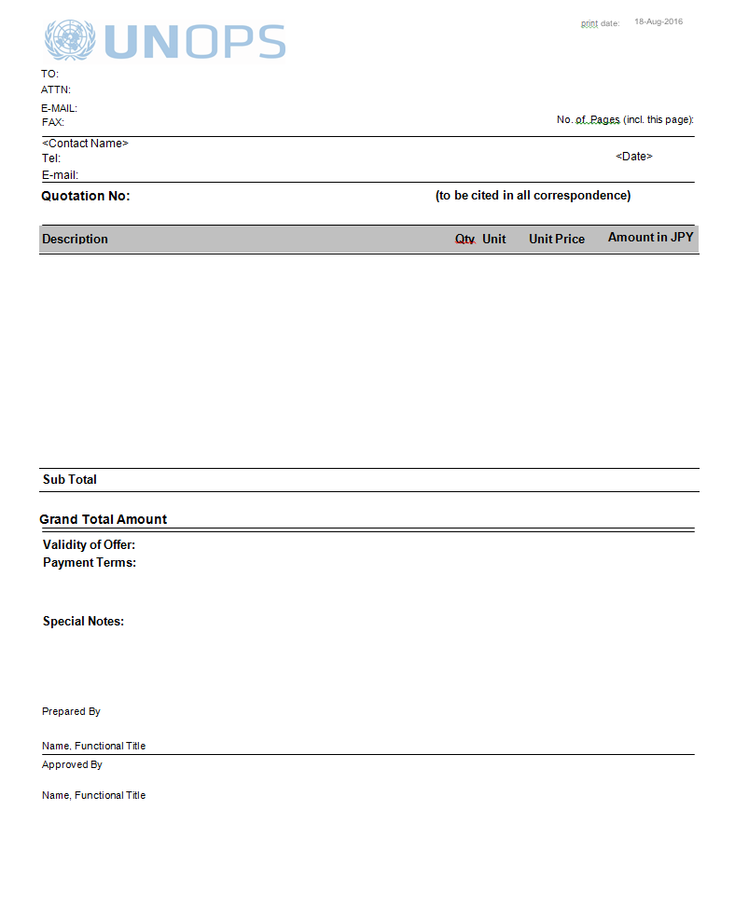

Step 3- By the Government

Upon receipt of the Quotation by UNOPS, the Government will obtain the necessary approvals to move forward with the quotation, and will confirm the acceptance of the Quotation either on UN Web Buy or through UNOPS representative and provide all necessary information for UNOPS to be able to finalize the Quotation and to proceed to Step 4.

Step 4- By UNOPS

Upon receipt of the Government’s confirmation, UNOPS will issue a Pro Forma Invoice, as provided in Annex II.

Step 5- By the Government

The Government shall make the payment to UNOPS based on the Pro Forma Invoice and within the 30 days price quote validity period.

ANNEX II

PROFORMA INVOICE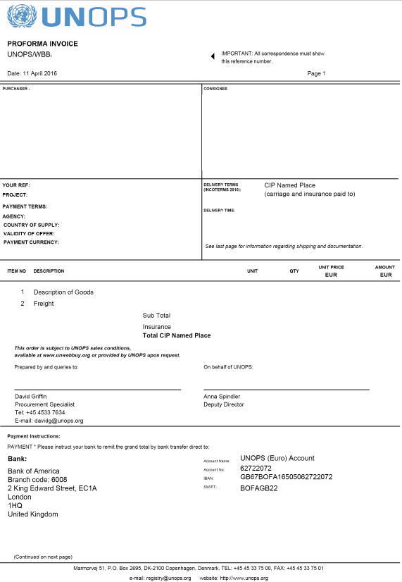

ANNEX III
ACCEPTANCE DOCUMENT
[to be prepared by the Government upon receipt of each shipment]

Date: [ ]
Attention:
Cc:

Reference: [insert Project Name, Loan/Credit/Grant number, Agreement Reference Number (as per Project’s Procurement Plan]

This Notice confirms receipt of the following Supplies:
Pro Forma Invoice No. [same as in the Pro Forma Invoice related to this shipment]

If partial delivery, please indicate which part(s): [please indicate item and quantity as per the Pro Forma Invoice related to this shipment]

Date the order arrived at the delivery destination (DD/MM/YY): ………….
Shipment quality (check one):
- Supplies fully received in good order including all parts ordered
- Supplies fully received in good order but with damaged or missing parts ordered
- Supplies missing
- Supplies damaged

Comments (optional) ……………………………………………………………………………..
…………………………………………………………………………………………………….

__________________________
Name

__________________________
Title

__________________________
Location (City, Country)

ANNEX III

REPORTING REQUIREMENTS

UNOPS shall submit the following reports on a [choose and insert “quarterly” or “semi-annual”] basis:

[Each report shall include:
- Summary of the status of delivery under each issued Pro Forma Invoice, date of Acceptance Certificate for each completed delivery; indication of any delays and the cause(s) of such delays, and the revised delivery schedule. At completion of the Agreement, a consolidated delivery report for all Supplies delivered over the duration of this Agreement;

- Interim Financial reports on the use of funds and the Payment Request for the next installment signed by the authorized UNOPS representative;

- A consolidated financial report on the use of funds (a sample format of consolidated summary is provided below).

The final Progress Report shall include a financial statement signed by an authorized official of the UNOPS:
“We hereby confirm to the best of our knowledge and based on the available records that the above amounts have been paid for the proper execution of the Agreement and in accordance with the terms and conditions thereof. We confirm that the share of supplies and equipment has not exceeded the share (percentage) approved for this Agreement. All documentation authenticating these expenditures has been retained by UNOPS in accordance with its document retention policy and will be available to UNOPS’s External Auditors for examination in the course of the audit of UNOPS’s Financial Statements.

Signed by:

Name and Title: Date: ___________________________

I. Sample of Interim Financial Statement

Country
World Bank Project:
IDA Grant/Loan No
Recipient:
UNOPS Case number:
Description: Supply of………………..
Grant Description:
Grant/Loan Duration:
Reporting Period:
 | INTERIM FINANCIAL STATEMENT AS AT ………..[date]
 | 1) INCOME
 | DEPOSITS
 | TOTAL FUNDS (A)
 | 2) PROJECT EXPENSES
 | PERIOD - CURRENT YEAR
 | 2016 | Project Expense
 |  | Net exchange loss
 |  | Indirect Cost
 | TOTAL PROJECT EXPENSES (B)
 |  | Project Advances (C)
 |  | Project Capitalised Asset (D)
 | PROJECT CASH BALANCE (E) = (A) - (B) - (C) - (D)
 |  | Open Purchase Orders (F)
 | 3) PROJECT FUND BALANCE (G) = (E) - (F)

II. Sample of Interim Financial Statements – CUMULATIVE

Country |  |  | Programmable Amount:
World Bank Project: |  |  | Total Funds Utilized:
IDA Grant/Loan No |  |  | For Reporting Period:
Recipient: |  |  | Current funds utilized
UNOPS Case number:
Supply of………………..
Grant Description: |  |  | Programmable Balance:
Grant Duration:
Reporting Period:
Cumulative Total Funds Utilized under Agreement No…….
 | Supply Items | Funded by this Grant/Loan | Funds utilized for the current [quarter /reporting period] | Cumulative funds utilized | Balance | Commitments | % of Grant/Loan Utilized
- Supplies
Pro Formal Invoice No………
Pro Formal Invoice No………
3
Sub-total for Supplies
- Related Services
1
2
3
Sub-total for Related Services
Grand total

References in this Agreement to the “World Bank” or “Bank” include both the International Bank for Reconstruction and Development (IBRD) and the International Development Association (IDA).
[Note to Users: “Project Name” refers to the project title as stated in the legal agreement (Financing Agreement) between the World Bank (a financier of this Agreement) and the Government. It should not be confused with the name of the UN Agency’s project or program financed from other sources]
References in this Agreement to the “World Bank” or “Bank” include both the International Bank for Reconstruction and Development (IBRD) and the International Development Association (IDA).
[Notes to Users: Payment information needs to be confirmed by UNOPS at the time of signing of a specific Agreement with the Government]

